§ Preparing the Board for Design Transfer

Keepouts

As well as the board shape, you should also define a placement and routing boundary around the edge of the board. This is done by placing objects on the keepout layer. Objects placed on this layer define 'no-go' zones for components and routing. Typically, you would define a shape just in from the edge of the board to restrict components and routing from being placed to close to the edge of the board. You can also define other routing and component keepouts areas for mechanical objects such as screw heads, or other mounting requirements.

To define a keepout that applies on all copper layers: place the tracks on the Keep-Out layer
You can also define layer-specific keepouts on any copper layer: Place » Keepout submenu (not included in the Gerber file )

Setting up Design Rules

For any placed object in the current design, you can quickly access information about which unary design rules apply to that object. Simply position the cursor over the object, right-click and select Applicable Unary Rules.
All defined design rules that could be applied to the selected object are analyzed and listed in the Applicable Rules dialog.
In a similar fashion, you can also access information about the binary design rules that apply between two placed objects in a design. Simply position the cursor over any object, right-click and select Applicable Binary Rules.

§ Working with the Board Insight System
F2 - Displays the Board Insight pop-up menu

Insight Lens:
SHIFT+M | Toggles the Insight Lens on or off. Use the lens when you need it.
SHIFT+N | Toggles the Insight Lens to move with the cursor, or drop it on the board at the current cursor location. Use this option to relocate the Insight Lens.
SHIFT+CTRL+M | Toggles the workspace zoom to display the contents of the Insight Lens. This allows you to see in more detail what is displayed in the Insight Lens.
SHIFT+CTRL+N | The Insight Lens moves with the cursor, centered around the cursor.
SHIFT+CTRL+S | Switches the Insight Lens into any of the available Single Layer modes (set in PCB Editor - Board Insight Display page of the Preferences dialog). The current layer objects are displayed in the lens, while all objects on other layers are masked or hidden, depending on the Single Layer mode being used.
ALT+Wheel-roll | Changes zoom level inside the Insight Lens.
ALT+Wheel-click | Same as SHIFT + CTRL + M, toggles the workspace zoom to display the contents of the Insight Lens.

Heads Up Display Data
SHIFT+H | Toggles the Heads Up Display on or off. Use this to decide when you want to use the display.
SHIFT+G | Toggles the location of the Heads Up Display to be at a fixed position on the board or allows it to be moved with the cursor. Use this option to move the Heads Up Display.
SHIFT+D | Toggles the display of the Delta Origin coordinates. The delta coordinates displays the distance, horizontally (dx) and vertically (dy), from the Delta origin coordinates. Use the Delta coordinates to gauge distance relative to a position on your board.
INS | Resets the Delta Origin to the current mouse coordinates. The distance horizontally and vertically the mouse is moved from the Delta Origin can be displayed in the Heads Up Display. This setting can be configured in the PCB Editor - Board Insight Modes page of the Preferences dialog.

Board Insight Pop-up Mode
Use the SHIFT + V shortcut to load the popup with information about violations currently under the cursor.
SHIFT + X loads the popup with information about any nets and components under the cursor.

Net Highlighting
To highlight any net on the board, CTRL + Click on any net, and everything in the workspace that is not part of that net is faded, making the routing stand out on all signal layers, as shown in the figure below. To highlight multiple nets hold the SHIFT key as you CTRL + Click on each net. CTRL + Click in free space to restore the display, or click the Clear button at the bottom right of the workspace.

§ Interactively Routing a Net

# Routing options shortcut
begin routing, and then press TAB. The routing options windows will pop up
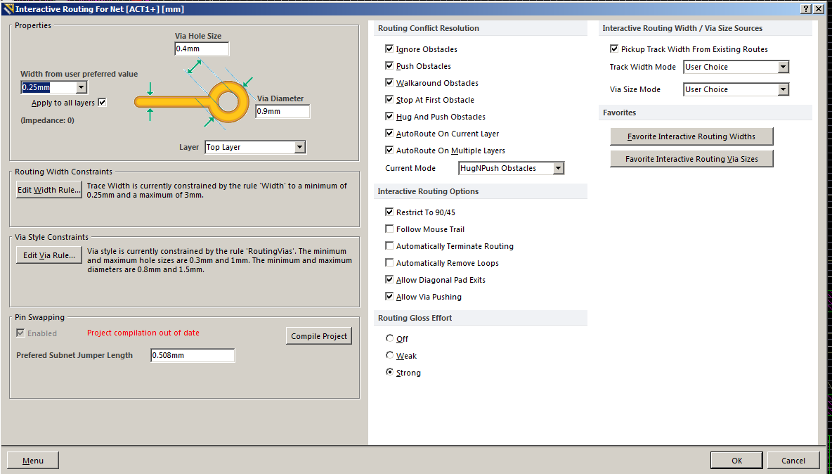

# Placing Tracks and Looking Ahead

There are two modes for committing tracks in relation to the cursor position.
Place mode | Look Ahead mode
placed all tracks right up to the current cursor position (place all currently uncommitted segments) | Place all tracks up to the current cursor position except the last segment. This can be handy if you are exploring path options.
Use the 1 shortcut key to toggle the mode on-the-fly.

# Controlling Corner Styles
Corner styles available include:
- Any angle
- 45°
- 45° with arc
- 90°
- 90° with arc
The styles are always available and can be cycled through using SHIFT + SPACEBAR
If the Restrict to 90/45 option is enabled in the PCB Editor - Interactive Routing page of the Preferences dialog, the arc and any angle corner options are unavailable.
Use SPACEBAR to toggle the direction of the corner.

# Automatic Connection Completion

The Interactive Router is able to attempt automatic completion (Auto-Complete) of connections to the target pad, hold CTRL and Left Click to instruct the Interactive Router to attempt to complete the current connection. This can make routing much faster than placing individual track segments, however, there are some limitations to Auto-Complete feature, as follows:
* Start point and target pad are on the same layer
* The route can be completed in accordance with design rules (provided that routing conflicts are not being ignored).

# Handling Routing Conflicts
Cycle through and select the desired conflict resolution mode using SHIFT + R.

1) Walking Around Obstacles
2) Pushing Obstacles
3) Hugging then Pushing Obstacles (This mode is a combination of Walkaround and Push functionality)
4) Ignoring Obstacles (you are free to route wherever you want)

The Routing Conflict Resolution settings used when you first start routing are configured in the PCB Editor - Interactive Routing page of the Preferences dialog
These same settings can also be accessed from the Interactive Routing for Net dialog which can be opened by pressing TAB during interactive routing.
The Status bar shows you the current routing mode being used

# Adding a Via Without Layer Change
Press the 2 key while routing to insert a via, however, keep routing on the current signal layer. Click to commit the via position.

# Glossing
There are three glossing modes that together define the range of glossing effort that can be applied by the Interactive Router:
1) Strong – in this mode a high level of glossing is applied, with the Interactive Router looking for shortest paths, smoothing out tracks, etc. This mode of glossing is typically useful in the early stages of the layout process, when the aim is to get a fair bit of the board routed quickly.
2) Weak – in this mode a low level of glossing is applied, with the Interactive Router considering only those tracks directly connected to, or in the area of, the tracks that you are currently routing (or tracks/vias being dragged). This mode of glossing is typically useful for fine-tuning track layout, or when dealing with critical traces.
3) Off – in this mode, glossing is essentially disabled. Note, however, that cleanup is still run after routing/dragging occurs to eliminate overlapping track segments for example. This mode is typically useful at the end stage of board layout, where the ultimate-level of fine-tuning is required (for example when manually dragging tracks, cleaning pad entries, etc).

# Protecting an Existing Route
To protect an existing route from being pushed/shoved as you route other nets, you need to lock those track segments.
The easiest way to do that is to Select Connected Copper (press the S shortcut key), open the Inspector panel (shortcut F11), and enable the Locked checkbox for the selected objects.

# Cross-Probing between Schematic and PCB
Open the PCB document, and hold down the Alt key while navigating objects on the schematic source - the same highlighting options will apply to both the navigated schematic objects and the corresponding PCB objects.
The cross-probing feature is accessed, from either Schematic or PCB Editors, using the Tools » Cross Probe command. There are two cross-probing modes available:
Continuous Mode – in this mode you remain in the source document, while cross-probing to different objects on the target document. Simply position the cursor over the required object and click or press Enter. The corresponding object will be highlighted on the target document. Continue cross-probing further objects, or right-click or press Esc to exit.
Jump To Mode – this mode allows cross-probing to a single object (think of it as 'single-shot cross-probing'), making the target document the active document. Simply position the cursor over the required object and Ctrl+click or press Ctrl+Enter. The corresponding object will be highlighted on the target document, with that document becoming the active document.

